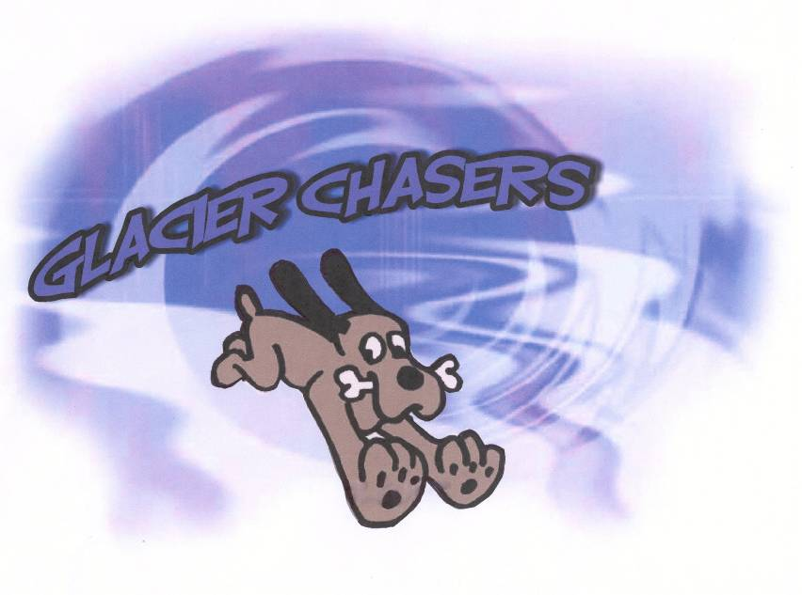
Glacier Chasers LLC  July 26-28, 2024  QUICKPAWS ARENA  265 Haskill Crossing Road  Whitefish, MT 59937  Judge:  Murrelet Halterman  Onyx, CA  Double Run Format  Building and Ring Surface info:  Indoors on dirt  Contact Surface:  Rubber matting  Crating Set up times:  Thursday night setup AFTER 4:00 PM  Fri, Sat & Sun AFTER 7:00 AM  Briefing at:  7:45 AM Fri, Sat & Sun  First dog on the line at:  8:00 AM Fri, Sat & Sun | Preliminary Class Order:  May change depending on weather, judges preference, time or number of entries  Friday  Class: Double Run Single Run  Tunnelers 2  Chances 2  Regular 2  Gamblers 2  Saturday  Class: Double Run Single Run  Regular 2  Weavers 2  Jumpers 2  Grounders 2  Sunday  Class: Double Run Single Run  Regular 2  Touch n Go 2  Chances 2

Entries Open on:  As soon as premium is posted  Entries Close on:  July 22, 2024 or when trial fills  (whichever comes first).  EARLY BIRD DISCOUNT: ENTRIES WITH FULL PAYMENT  MUST BE POSTMARKED BY July 5, 2024.  Crating available:  Inside arena on dirt; bring shade if crating from or near vehicle as parking is on south and west sides of arena.  Entry Limits:  500 runs /day  Move ups:  Allowed day to day - no same day move ups.  Day of show Entries:  Allowed until trial fills.  Refunds:  Bitches in season or injured dogs are due a full refund with veterinarian verification. Other situations are considered on an individual basis and may have up to $4.00  per run retained.  Veterinarian:  Central Valley Animal Hospital  24 hour emergency service  3650 Hwy 2 East, Kalispell  406-755-8505 | Show Committee  Trial Chair/ Pre-trial Secretary:  Carol Scranton  myquickpaws@gmail.com  406-250-8460  Trial Day Secretary:  Susan Randall  Confirmations:  Emailed when completed entry received and information entered.  Food info:  Coffee and bottled water available all day.  Lunches – supplied.  Dinner – annual “BBQ”.  Volunteer info:  Volunteers are greatly appreciated! Please sign up on the worker board.  Awards and Ribbons:  1st – 4th place ribbons in each class.  (Chances is pass/fail with no placements).  Qualifying ribbons.  Titling rosettes for titles earned at this trial.  Special NATCH awards.  Equipment info:  Rubber surfaced dogwalk & A-frame.  Tunnels, wingless jumps, hoops, barrels.  24” spaced weave poles.
Jump Height Info:
MEASURING
Effective Jan 1st 2025 All dogs will be required to have a permanent height card on file
Measurement forms may be obtained at:
https://www.nadac.com/WPsite/wp-content/uploads/2021/06/Permanent-Height-Card-form-6.4.21.pdf
Dogs which require measuring:
Dogs in the Proficient Category, Novice, Open or Elite jumping 4”, 8”, 12” or 16”

Dogs which do not need to be measured:
Dogs jumping 16” in the Veteran or Junior Handler Division
Dogs jumping 20”
Dogs in the Skilled Category
Dogs with a permanent height card
Dogs listed on the Height Exemption List
JUMP HEIGHTS
There are four Standard Division-Proficient jump heights: 8”, 12”, 16”, and 20”.
There are four Standard Division-Skilled jump heights: 4”, 8”, 12”, and 16”.
There are four jump heights for the Veterans and Junior Handler divisions: 4”, 8”, 12”, and 16”.
Please see the NADAC Rulebook for the full jump height table
Brief Summary of Rules:
Please refer to www.nadac.com for a full explanation of all NADAC rules and up to date information.

- Please note that NADAC trials should provide a safe and fun environment for both exhibitors and their dogs.
- Aggressive dogs will not be tolerated and will be excused from the trial.
- The show committee has the right to refuse any entry. Anyone not currently in good standing with NADAC will not be allowed to enter this trial.
- Exhibitors, through submission of entry, acknowledge that they are knowledgeable of NADAC rules and regulations, and agree to abide by all rules in effect at the time of this trial.
- No entry fee will be refunded if the trial cannot open or be completed by reasons of riots, civil disturbances, fire, acts of God, public emergency, an act of a public enemy, or any other cause beyond the control of the organizing committee.
- Checks not honored by the bank do not constitute a valid entry fee. There will be a $25.00 service charge for bank returned checks.
- Dog must be registered and have a valid registration number before entries will be accepted. https://www.nadac.com/register-your-dog/
- A copy of the current Exhibitors Handbook may be downloaded free from the NADAC web site: www.nadac.com
- Bitches in heat, lame, or blind dogs are ineligible for entry, as is any dog with a deformity which may cause a judge to not be able to reasonably assess the dog’s ability to function and perform agility obstacles safely, and in a manner that is in the best interest, health and welfare of the dog.
- No food, clickers, or other aids or devices shall be permitted on the course or within 10 feet of the ring. Food or a small non-audible toy can be in a secure container (ziplock bag is acceptable) in your pocket during your run but you cannot indicate to the dog it is there. All handlers may bring a non-audible toy into the ring for training purposes. They cannot earn a Qualifying score and must declare to the judge they are training before they commence their run. Please read the Exhibitor’s Handbook for more information about toys and training in the ring.
- The sponsoring clubs will not be responsible for the loss or damage to any dog exhibited, or for the possessions of any exhibitor whether the result be accident or other cause. It is distinctly understood that every dog at this event is in the care and control of his owner or handler during the entire time the dog is on the show premises.

Glacier Chasers LLC * July 26-28, 2024
Make Checks Payable to: Glacier Chasers LLC MAIL entries with correct fees to: Carol Scranton, 339 Moose Run Drive, Whitefish, MT 59937
Owner |  |  |  |  | Dog
Name |  |  |  |  | Call Name
Address |  |  |  |  | NADAC Reg #
City/State/Zip |  |  |  |  | Date of Birth
Phone |  |  |  |  | Height at Withers
Email |  |  |  |  | Breed
Handler, If not owner |  |  |  |  | Emergency Contact Name/Phone
PLEASE INCLUDE A COPY OF YOUR DOG’S HEIGHT CARD
CATEGORY: PROFICIENT ☐ SKILLED ☐
DIVISION: STANDARD ☐ VET DOG ☐ VET HANDLER ☐ JUNIOR HANDLER ☐
I WANT MY DOG TO JUMP: ☐ 4 ☐ 8 ☐ 12 ☐ 16 ☐ 20
Class | Level |  |  |  | Day
 | Intro | Novice | Open | Elite | Friday | Saturday | Sunday
Regular | ☐ | ☐ | ☐ | ☐ | Rd 1☐ Rd 2☐ | Rd 1☐ Rd 2☐ | Rd 1☐ Rd 2☐
Chances | ☐ | ☐ | ☐ | ☐ | Rd 1☐ Rd 2☐ |  | Rd 1☐ Rd 2☐
Jumpers | ☐ | ☐ | ☐ | ☐ |  | Rd 1☐ Rd 2☐
Touch n Go | ☐ | ☐ | ☐ | ☐ |  |  | Rd 1☐ Rd 2☐
Weavers | ☐ | ☐ | ☐ | ☐ |  | Rd 1☐ Rd 2☐
Tunnelers | ☐ | ☐ | ☐ | ☐ | Rd 1☐ Rd 2☐
Gamblers | No Intro | ☐ | ☐ | ☐ | Rd 1☐ Rd 2☐
Grounders | ☐ | ☐ | ☐ | ☐ |  | Rd 1☐ Rd 2☐
In consideration of the acceptance of this entry, I/we certify that I/we have knowledge of, and are familiar with, and agree to abide by, the Rules and Regulations of NADAC in effect at the time of this trial, and by any additional rules and regulations as approved by NADAC for this trial. I/we certify that the dog entered is not a hazard to persons or other dogs. I/we further agree to be bound by the “Agreement” printed on page 5 of this premium

EARLY BIRD FEES: TO RECEIVE THIS DISCOUNT, ENTRIES MUST BE
POSTMARKED BY July 5, 2024 AND INCLUDE FULL PAYMENT.(Cashed on receipt)
STANDARD FEES:
□ 1-10 Runs @$11/run = ___________ □ 1-10 Runs @$12/run = ___________
□ 11-19 Runs. @$10/run = ___________ □ 11-19 Runs @$11/run = ___________
□ 20+ Runs @$9/run = ___________ □ 20+ Runs @ $10/run = ___________
□ Junior Handler @$5/run = ___________ □ Junior Handler @$6/run = ___________

**For entries emailed/postmarked after closing (July 22) and NEW “day of” entries, all runs are $13.
Adding runs to existing pre-entry at the trial will be at your pre-entry rate.

TOTAL NUMBER OF RUNS ENTERED (all dogs) ___________
TOTAL ENTRY FEES (all dogs) $_________
SAT. DINNER ($15/person) $_________ (enter # of chosen entrée: ___Burger; ___ Chicken Breast; ___Pork Ribs.
DRY CAMPING ($10/night) $_________
PLUG-IN($20/night) $_________ TOTAL ENCLOSED $_____________
(LIMITED CAMPING - to reserve email gcagility@gmail.com)

Owner/Exhibitor: _______________________________________________________________ Date___________

Parent/ Legal Guardian of Junior Handler____________________________________________ Date___________

AGREEMENT

The person who signs this agreement represents that he/she is authorized to enter into this agreement on behalf of both exhibitor and the owner of entered dog. In consideration of acceptance of this entry:

1.1. As used here "NADAC" means the North American Dog Agility Council, LLC, its members, officers, directors, employees, show chairs, show committees and agents.
1.2. Exhibitor/owner agree to abide by the rules and regulations of NADAC and any other rules and regulations appearing in the premium for this event.
1.3. Exhibitor/owner certify that the entered dog is not a hazard to persons, dogs or property and that the entered dog's rabies vaccination is current in accordance with the requirement of the state in which the dog resides.
1.4. Exhibitor/owner acknowledge all hazards presented by the event and the event premises,
including, but not limited to, the condition of the surface, restrooms, security measures or lack of, electrical appliances, fittings, show rings, parking areas and the presence of unfamiliar animals and people; exhibitor and owner assume the risk of any harm arising from these.
1.5. Exhibitor/owner releases NADAC (including its respective officers, directors, employees, and members), Glacier Chasers (including its officers, directors, members, and event organizing
committee), and Quickpaws Arena (including its officers, agents, and employees) and will
defend them and hold them harmless from all present and future loss, injury, damage, claims, demands, and liabilities involving the entered dog, the event or event premises. Without limiting the generality of the foregoing hold harmless provisions, exhibitor/owner hereby specifically assumes sole responsibility for and agrees to indemnify and save the aforementioned parties harmless from any and all loss and expenses (including legal fees) by reason of the liability imposed by law upon any of the aforementioned parties for damages because of bodily injuries, including death, at any time in consequence of my (our) participation in this event, howsoever such injury or death may be caused and whether or not the same may have been caused or may have been alleged to have been caused by negligence of the aforementioned parties or any of their employees or agents or any other persons.

NOTICE FROM MANAGEMENT
Glacier Chasers, LLC, its members, and the owners of the show premises, will not be responsible for the loss or damage to any dog exhibited, or for the loss or damage to the possessions of any exhibitor, whether the result was by accident or any other cause. It is distinctly understood that every dog at this event is in the care and custody and control of his owner or handler during the entire time the dog is on the show premises. It is also distinctly understood that any persons being guests of the signing exhibitor are the sole responsibility of that exhibitor and thus bound by this agreement. Any exhibitor whose dogs and/or children create unnecessary disturbances or repeatedly engage in unsafe or disruptive behavior shall, at the discretion of the Show Committee, be asked to leave the show site. In such case, no refund of fees paid will be made.

Lodging Info and Directions:

***My Place Hotel 755 Treeline Rd, Kalispell, MT 59901 (406) 752-4847***
My Place was able to give us a block of rooms. Rate is a bit high, but significantly less than others in the area.
Rooms blocked for July 25-29 (Thursday thru Sunday)
$205 per night plus tax. Double Queen or Single King.
No pet fee.
Cutoff date is June 25 – FIRM.
To reserve use this link only.. Please DO NOT CALL to make your reservation as it may not be clear to the front desk. YOU MUST COPY & PASTE THIS LINK IN YOUR BROWSER FOR IT TO WORK PROPERLY.
https://be.synxis.com/?Hotel=7705&Chain=19777&group=Glacier Chasers 7-24

SOME OTHER DOG FRIENDLY MOTELS (Check with motels directly for rates, taxes and pet policy)
Pine Lodge, 920 Spokane Ave Whitefish, MT 59937 Phone: (877) 600-4241

Best Western Rocky Mountain Lodge, 6510 US-93 Whitefish, MT 59937 Phone: (406) 862-2569

Best Western Plus, 255 Montclair Dr Kalispell, MT 59901 Phone: (406) 257-5255
Holiday Inn Express, 275 Treeline Rd Kalispell, MT 59901 Phone: (406) 755-7405
Whitefish RV Park, 6404 HWY 93 S, Whitefish MT 59937 – FULL HOOKUPS – (406) 862-7275 – whitefishrvpark@gmail.com

DRY CAMPING ALLOWED AT QUICKPAWS ARENA AS SPACE PERMITS- $10 PER NIGHT. LIMITED PLUG INS AVAILABLE- $20 PER NIGHT. ALL SPOTS MUST BE RESERVED – SEND REQUEST BY SEPARATE EMAIL TO gcagility@gmail.com .

DIRECTIONS TO QUICKPAWS ARENA - 265 Haskill Crossing Road
FROM KALISPELL:
Proceed north on HWY 93 through Whitefish to Baker Ave. Turn right onto Baker Ave, over the viaduct. Turn right onto E. Edgewood. Proceed approximately 2.5 miles. Turn left onto Haskill Basin Road. Continue about 0.8 miles (the road curves 90 degrees to the right) and then turn right onto Haskill Crossing Road. Keep to the right and follow to the end of the road. Quickpaws Arena will be on the left.

FOOD OPTIONS FOR GLACIER CHASERS TRIAL

COFFEE WILL BE AVAILABLE ALL DAY – bringing your own mug/container will be appreciated.

BOTTLED WATER WILL BE AVAILABLE ALL DAY.

LUNCH will be supplied for exhibitors and volunteers – may include sandwiches, soup, salads, chili, etc. Unfortunately special dietary requirements cannot be accommodated. Please understand that we will not be able to plan for or feed family and friends who come to observe and support you.

SATURDAY DINNER

“BBQ” - Please enclose with your entry or return to me by email (gcagility@gmail.com) NO LATER THAN 5 pm Saturday, July 20. No changes or additions can be made after that time. Hot entrees, salad, sides & desserts will be served. A variety of beverages will be set out also. Cost is $15 per meal. Please include payment with entry. If you are sending this separate from your entry, you may pay at check in.

Name ________________________

# dinner reservations ___________

Entrée choice & number: ____Burger ____Chicken Breast _____Pork Rib

